**MR Injuries**

I generated a series of plots to assess the prevalence and distribution of MR injuries over time and across mines. In this investigation, I specifically probed the prevalence and distribution of two measures of MR injuries:

1. The number of MR injuries per hour worked in each mine, and
2. The share of total injuries that are MR injuries, per hour worked in each mine.

The first variable probes the frequency of MR injuries that occur in each mine, and the second probes the frequency of the ratio of MR injuries that occur in each mine. Both variables account for exposure to injuries.

**Over Time**

**Overall**

For each year, I calculated the average and median number of MR injuries per hour worked across all active mines in that year. These plots are presented below.

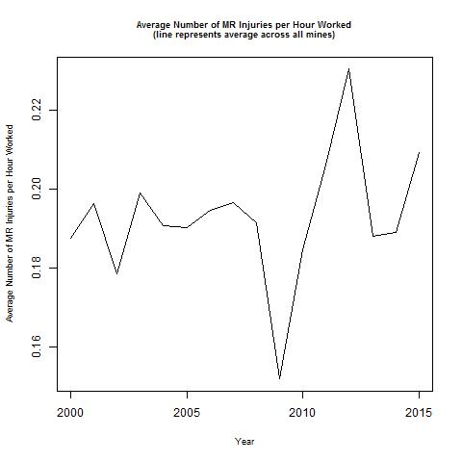 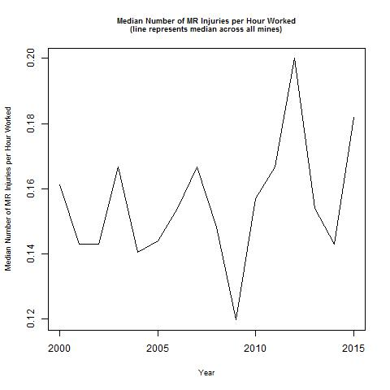

These plots both show dramatic drops and spikes in the number of MR injuries per hour worked around 2010. Otherwise, the number of MR injuries per hour worked fluctuates year to year, but remains fairly consistently around a center (using the average measure, 0.19; using the median measure, 0.15). Notably, the plot of the median number of MR injuries per hour worked shows a similar trend to that of the average number of MR injuries per hour worked, suggesting that the apparent fluctuations are not the result of a few mines with outlying values.

For each year, I similarly calculated the average and median share of total injuries that are MR injuries, per hour worked across all active mines in that year. These plots are presented below.

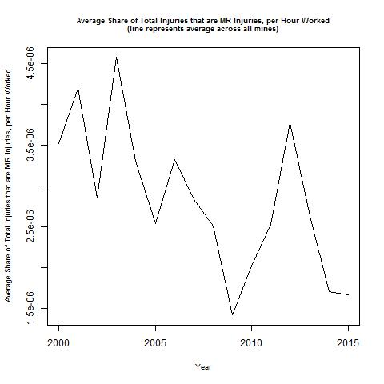 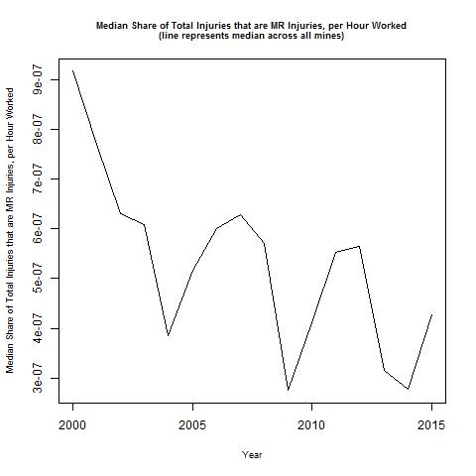

These plots suggest a decline in the share of total injuries that are MR injuries over time. Notably, the plot of the median share of total injuries that are MR injuries, per hour worked shows a similar trend to that of the average share of total injuries that are MR injuries, per hour worked, suggesting that the apparent fluctuations in this outcome over time are not the result of a few mines with outlying values. That said, the plot of the median share of total injuries that are MR injuries, per hour worked does depress the spikes apparent in the plot of the average share of total injuries that are MR injuries, per hour worked, suggesting that there are *some* mines with extreme values.

**By Hours**

I grouped mines by the number of hours worked in two ways:

1. Dynamically: Every year, a mine was classified as large if it was at or above the 80th percentile for number of hours worked (among active mines in that quarter), as medium if it was at or above the 50th percentile for number of hours worked (but below the 80th percentile for number of hours worked) (among active mines in that quarter), and as small if it was below the 50th percentile for number of hours worked (among active mines in that quarter). This method is described as “dynamic” because the mines comprising the large, medium, and small hours groups can change from year to year; relatedly, a mine can be considered small, medium, and/or large over its lifetime in our dataset.
2. Statically: A mine is considered as large if it is in the 80th percentile for number of hours worked (among active mines in that quarter) for every quarter in which it is active, and is classified as small otherwise. This method is described as “static” because the mines comprising the large and small hours groups does not change, and relatedly, a mine can only be considered small *or* large.

For each year, I calculated the average and median number of MR injuries per hour worked across all active mines in that year, separate for each of the groups described above. The plots displaying the groups of mines defined dynamically are presented below (red = small, green = medium, blue = large).

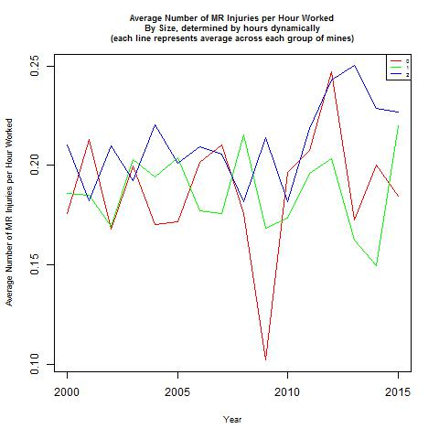 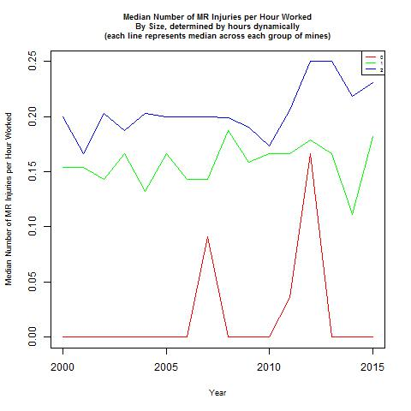

The plot of the average number of MR injuries per hour worked shows that the groups’ injuries fluctuate slightly differently, but generally center around 0.20; however, it appears there is more dramatic fluctuation – for all groups – in the 2010-2015 time period. In contrast, the plot of the median number of MR injuries per hour worked suggests that the different groups’ have different numbers of MR injuries per hour worked and also feature different trends over time. For the entire study period, small mines have fewer MR injuries per hour worked than medium mines, which have fewer MR injuries per hour worked than big mines. Large and medium mines experience a fairly consistent number of MR injuries per hour worked, whereas small mines exhibit two large spikes in more recent years, mirroring (and perhaps driving) the trend apparent in the plot of the median number of MR injuries per hour worked across all mines.

The plots displaying the groups of mines defined statically are presented below (small = red, large = blue).

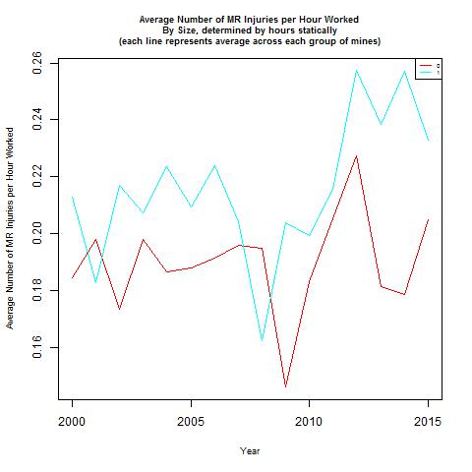 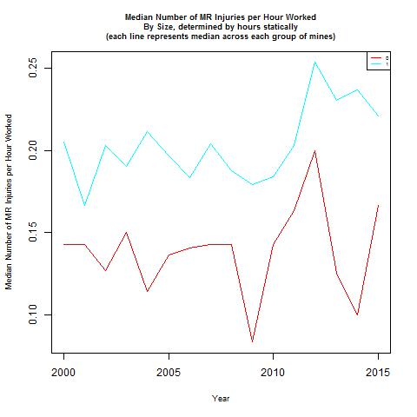

Both plots show that the different groups’ have different numbers of MR injuries per hour worked, but feature similar trends over time. Though small mines have fewer MR injuries per hour worked than large mines, both groups show trends mirroring the trend apparent in the plots of the average and median number of MR injuries per hour worked across all mines – that is, a dramatic drop and peak around 2010. Notably, the plot of the median number of MR injuries per hour worked shows somewhat depressed spikes compared to the plot of the average number of MR injuries per hour worked, suggesting that these spikes, particularly in the group of small mines, may be driven by a few mines with extreme values.

For each year, I also calculated the average and median share of total injuries that were MR injuries per hour worked across all active mines in that year, separate for each of the groups described above. The plots displaying the groups of mines defined dynamically are presented below (red = small, green = medium, blue = large).

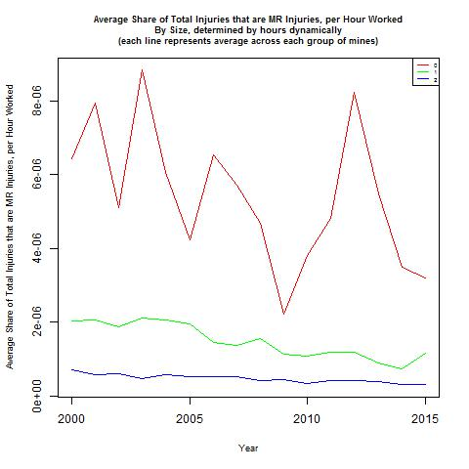 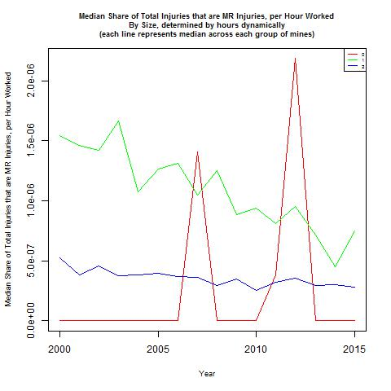

The plot of the average share of total injuries that are MR injuries, per hour worked, suggests that the different groups’ have different levels and also feature different trends over time for this outcome. For the entire study period, small mines have a higher share of total injuries that are MR injuries per hour worked than do medium mines, which have a higher share of total injuries that are MR injuries per hour worked than do big mines. Large and medium mines experience a fairly consistent share of total injuries that are MR injuries per hour worked, whereas small mines exhibit more dramatic fluctuations. In contrast, the plot of the median share of total injuries that are MR injuries, per hour worked, suggests that small mines generally have a lower share of total injuries that are MR injuries per hour worked than do medium and large mines except for two extreme peaks.

The plots displaying the groups of mines defined statically are presented below (red = small, blue = large).

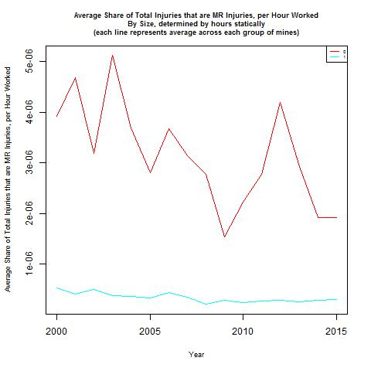 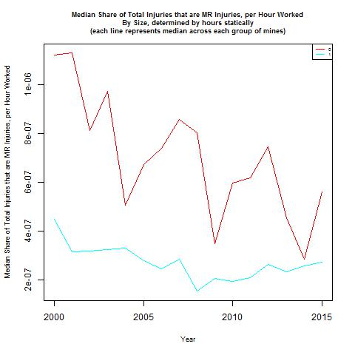

Both plots show that the different groups’ have different shares of total injuries that are MR injuries per hour worked, as well as feature different trends over time. In both plots, for the entire study period, small mines have a higher share of total injuries that are MR injuries per hour worked than do large mines. Small mines also experience more extreme fluctuations in this outcome than do large mines, which exhibit a fairly consistent (and low) share of total injuries that are MR injuries per hour worked.

**By Employment**

I grouped mines by the number of employees in two ways (mirroring the grouping based on hours described above):

1. Dynamically: Every year, a mine was classified as large if it was at or above the 80th percentile for number of employees (among active mines in that quarter), as medium if it was at or above the 50th percentile for number of employees (but below the 80th percentile for number of hours worked) (among active mines in that quarter), and as small if it was below the 50th percentile for number of employees (among active mines in that quarter). This method is described as “dynamic” because the mines comprising the large, medium, and small hours groups can change from year to year; relatedly, a mine can be considered small, medium, and/or large over its lifetime in our dataset.
2. Statically: A mine is considered as large if it is in the 80th percentile for number of employees (among active mines in that quarter) for every quarter in which it is active, and is classified as small otherwise. This method is described as “static” because the mines comprising the large and small hours groups does not change, and relatedly, a mine can only be considered small *or* large.

For each year, I calculated the average and median number of MR injuries per employees across all active mines in that year, separate for each of the groups described above. The plots displaying the groups of mines defined dynamically are presented below (red = small, green = medium, blue = large).

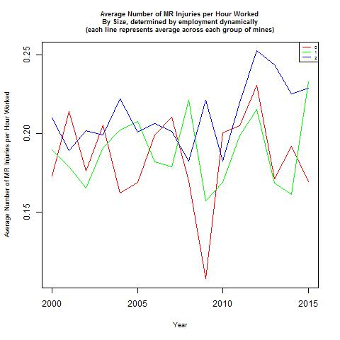 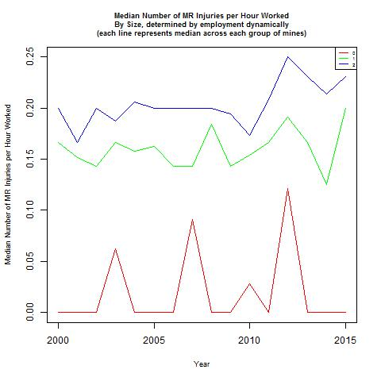

These plots tell a similar story as the corresponding ones for groups based on hours.

The plots displaying the groups of mines defined statically are presented below (small = red, large = blue).

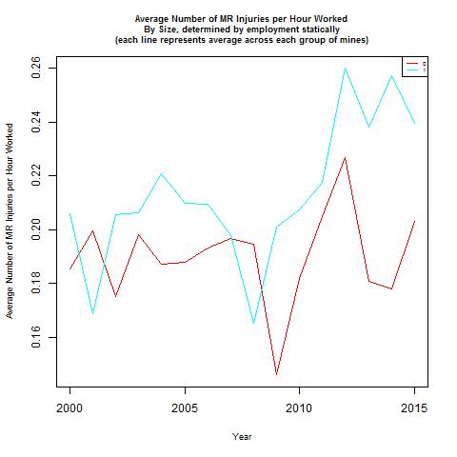 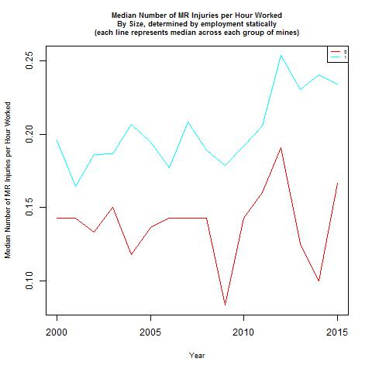

These plots tell a similar story as the corresponding ones for groups based on hours.

For each year, I also calculated the average and median share of total injuries that were MR injuries per hour worked across all active mines in that year, separate for each of the groups described above. The plots displaying the groups of mines defined dynamically are presented below (red = small, green = medium, blue = large).

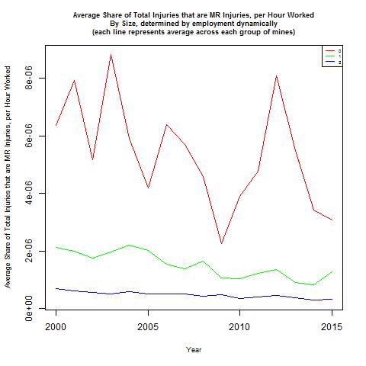 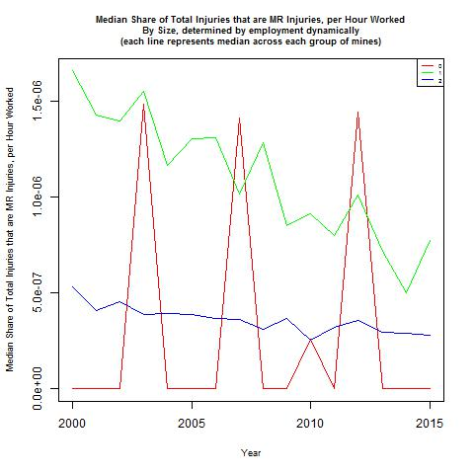

These plots tell a similar story as the corresponding ones for groups based on hours.

The plots displaying the groups of mines defined statically are presented below (red = small, blue = large).

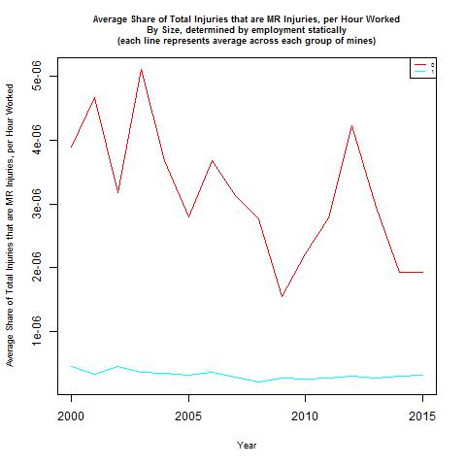 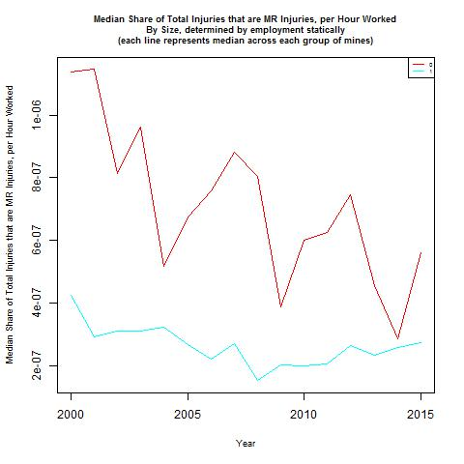

These plots tell a similar story as the corresponding ones for groups based on hours.

**By Production**

I grouped mines by their coal production in two ways (mirroring the grouping based on hours and number of employees described above):

1. Dynamically: Every year, a mine was classified as large if it was at or above the 80th percentile for coal production (among active mines in that quarter), as medium if it was at or above the 50th percentile for coal production (but below the 80th percentile for number of hours worked) (among active mines in that quarter), and as small if it was below the 50th percentile for coal production (among active mines in that quarter). This method is described as “dynamic” because the mines comprising the large, medium, and small hours groups can change from year to year; relatedly, a mine can be considered small, medium, and/or large over its lifetime in our dataset.
2. Statically: A mine is considered as large if it is in the 80th percentile for coal production (among active mines in that quarter) for every quarter in which it is active, and is classified as small otherwise. This method is described as “static” because the mines comprising the large and small hours groups does not change, and relatedly, a mine can only be considered small *or* large.

For each year, I calculated the average and median number of MR injuries per hour worked across all active mines in that year, separate for each of the groups described above. The plots displaying the groups of mines defined dynamically are presented below (red = small, green = medium, blue = large).

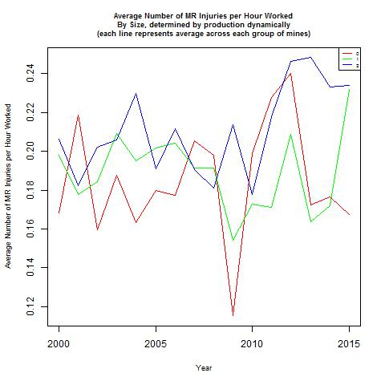 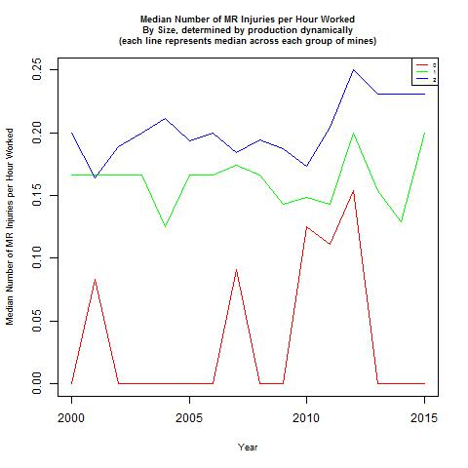

These plots tell a similar story as the corresponding ones for groups based on hours and employment.

The plots displaying the groups of mines defined statically are presented below (small = red, large = blue).

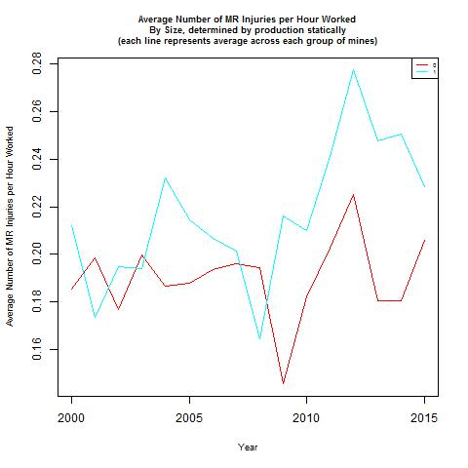 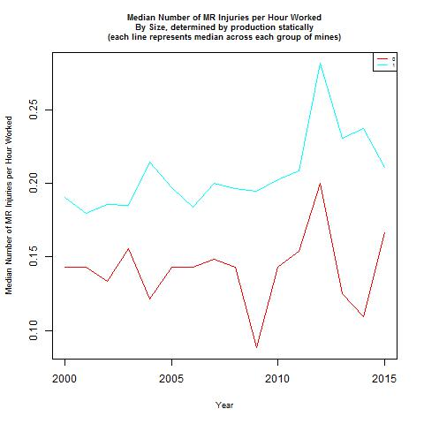

These plots tell a similar story as the corresponding ones for groups based on hours and employment.

For each year, I also calculated the average and median share of total injuries that were MR injuries per hour worked across all active mines in that year, separate for each of the groups described above. The plots displaying the groups of mines defined dynamically are presented below (red = small, green = medium, blue = large).

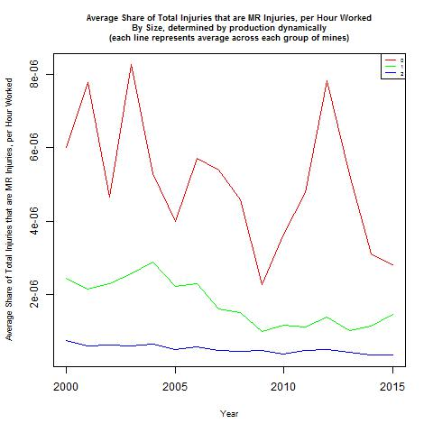 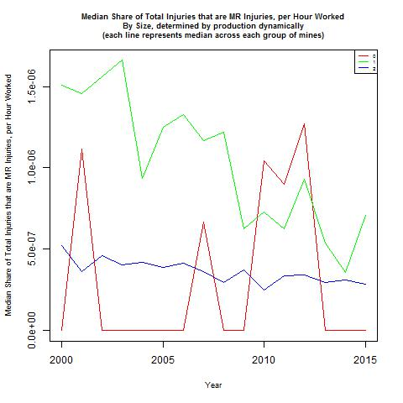

These plots tell a similar story as the corresponding ones for groups based on hours and employment.

The plots displaying the groups of mines defined statically are presented below (red = small, blue = large).

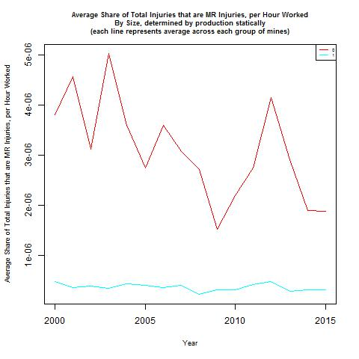 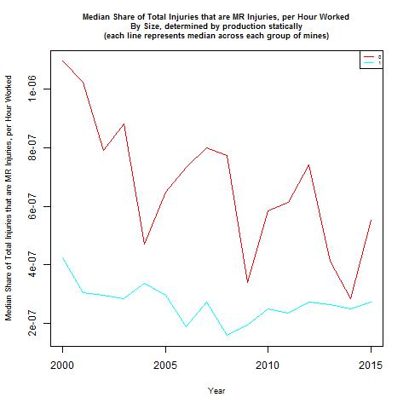

These plots tell a similar story as the corresponding ones for groups based on hours and employment.

**By District**

For each year, I calculated the average and median number of MR injuries per hour worked across all active mines in that year, separate for each district. These plots are presented below.

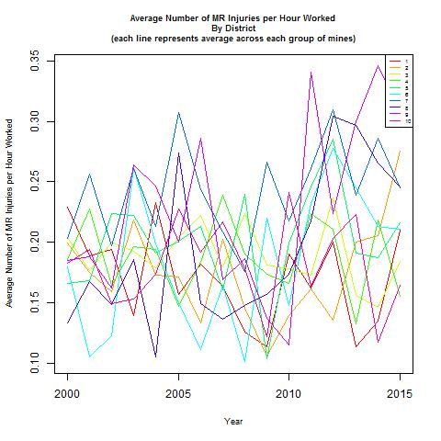 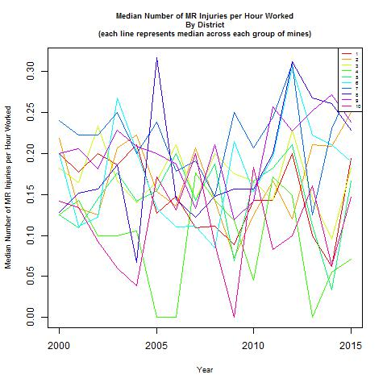

Both plots show that there is considerable variation in the number of MR injuries per hour worked both across districts at each time, and within each district over time. Moreover, the time trends within each district do not follow a clear pattern.

For each year, I also calculated the average and median share of total injuries that were MR injuries per hour worked across all active mines in that year, separate for each district. These plots are presented below.

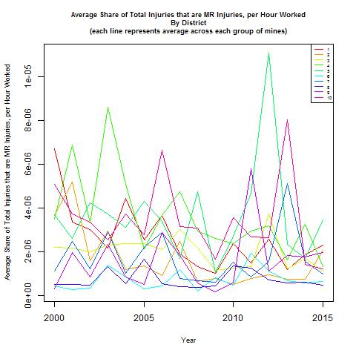 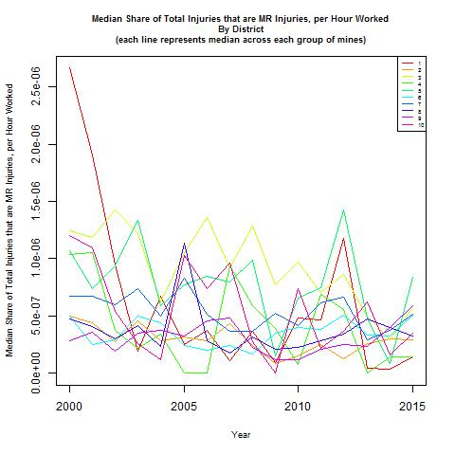

As with the plots concerning the number of MR injuries per hour worked, these plots show that there is considerable variation in the share of total injuries that are MR injuries per hour worked both across districts at each time, and within each district over time. And again, these time trends within districts do not follow a clear pattern.

**By Appalachia**

For each year, I calculated the average and median number of MR injuries per hour worked across all active mines in that year, separate for mines in Appalachia (blue) and mines not in Appalachia (red). These plots are presented below.

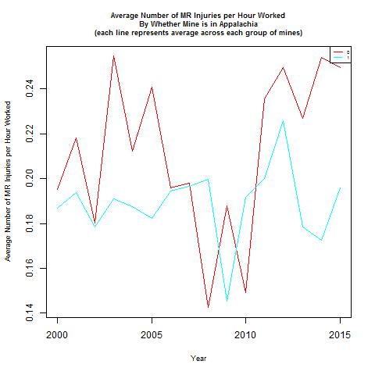 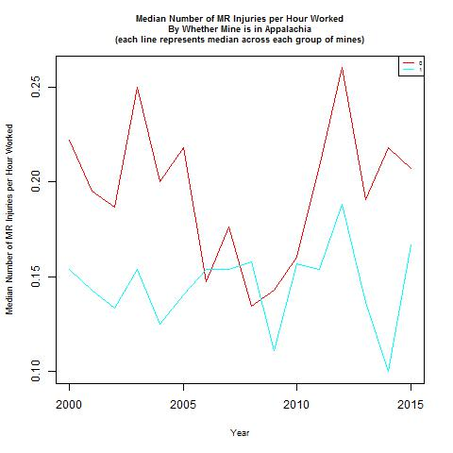

Both plots show that over many years, mines not in Appalachia have more MR injuries per hour worked than mines in Appalachia. However, there are some years in which this is not the case. Additionally, the plots show that both groups of mines exhibit trends mirroring the trend apparent in the plot of the median number of MR injuries per hour worked across all mines, though the spikes around 2010 are more extreme for mines not in Appalachia.

For each year, I also calculated the average and median share of total injuries that were MR injuries per hour worked across all active mines in that year, separate for mines in Appalachia (blue) and mines not in Appalachia (red). These plots are presented below.

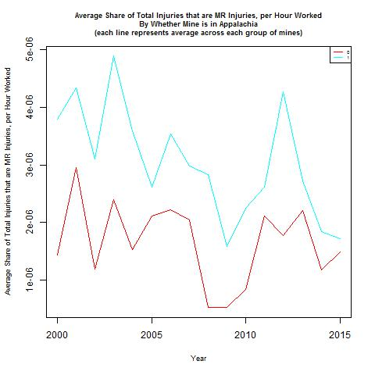 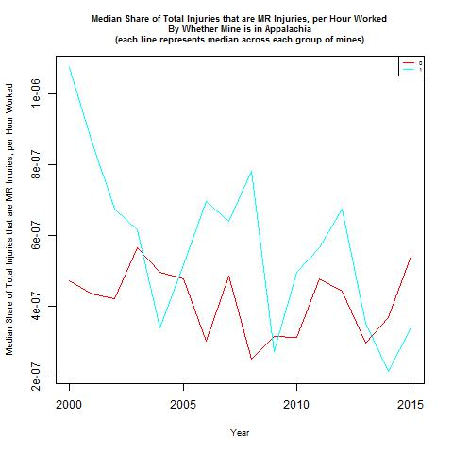

Unlike the plots concerning the number of MR injuries per hour worked, these plots show that it is mines that are in Appalachia that have a higher share of total injuries that are MR injuries per hour worked compared to mines not in Appalachia. These plots also suggest that mines in both groups exhibit similar time trends.

**By Safety Committee**

For each year, I calculated the average and median number of MR injuries per hour worked across all active mines in that year, separate for mines that had no safety committee (red) and mines that had a safety committee (blue). These plots are presented below.

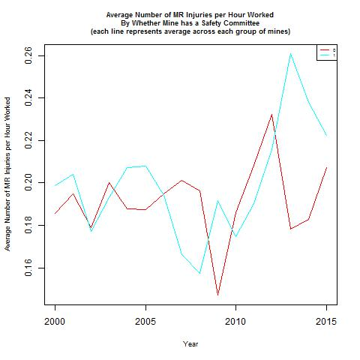 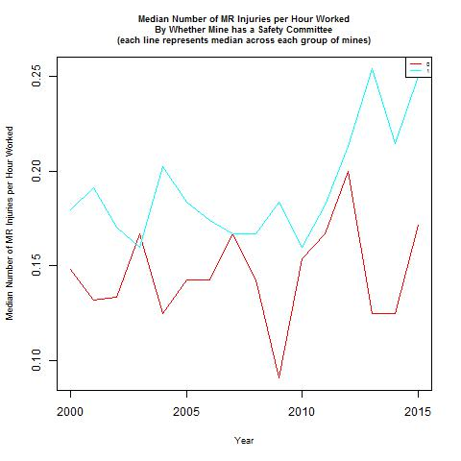

Both plots show that over many years, mines without a safety committee had fewer MR injuries per hour worked than mines that had a safety committee. However, there are some years in which this is not the case. Notably, the plot of the median number of MR injuries per hour worked shows depressed spikes compared to the plot of the average number of MR injuries per hour worked, suggesting that the spikes in the average plot are due to *some* mines with extreme values.

For each year, I also calculated the average and median share of total injuries that were MR injuries per hour worked across all active mines in that year, separate for mines that had no safety committee (red) and mines that had a safety committee (blue). These plots are presented below.

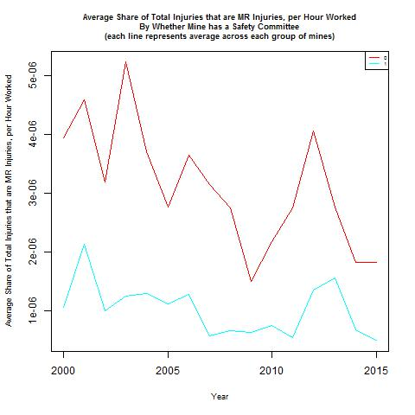 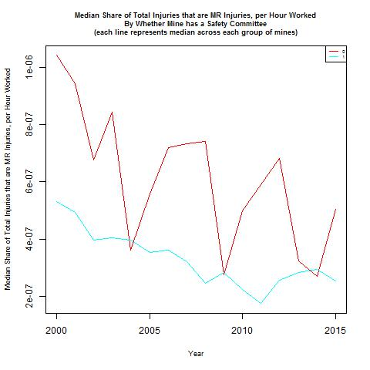

Unlike the plots concerning the number of MR injuries per hour worked, these plots show that it is mines that without a safety committee that have a higher share of total injuries that are MR injuries per hour worked compared to mines without a safety committee. The plot of the average share of total injuries that were MR injuries per hour worked suggests that mines in both groups exhibit similar time trends. In contrast, the plot of the average share of total injuries that were MR injuries per hour worked suggests that mines without a safety committee experience more dramatic fluctuations in the share of total injuries that were MR injuries per hour worked than do mines with a safety committee.

**Across Mines**

I calculated the average and the median number of MR injuries per hour worked in each mine (i.e., average and median over time). The histograms for these measures are presented below.

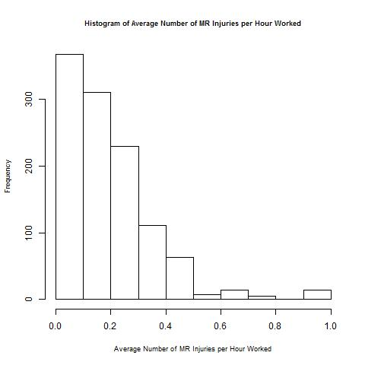 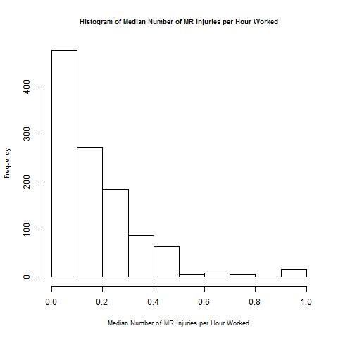

These histograms both show that mines have a distribution of average and median number of MR injuries per hour worked skewed towards 0.

I also calculated the average and the median share of total injuries that are MR injuries per hour worked in each mine (i.e., average and median over time). The histograms for these measures are presented below.

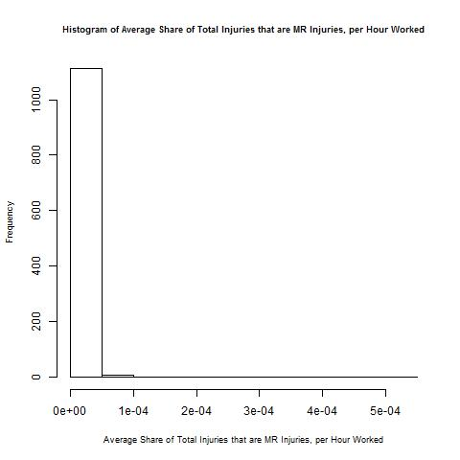 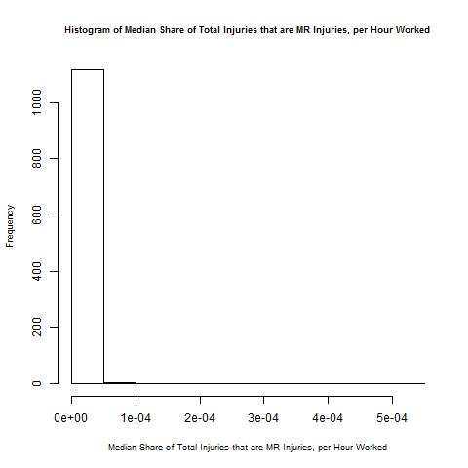

As with the histograms of average and median number of MR injuries per hour worked, these histograms both show that mines have a distribution of average and the median share of total injuries that are MR injuries per hour worked skewed towards 0.

For each mine, I calculated the correlation between the number of MR injuries per hour worked and year, and between the share of total injuries that are MR injuries per hour worked and year. The histograms for these measures are presented below.

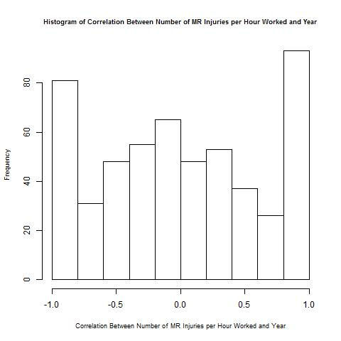 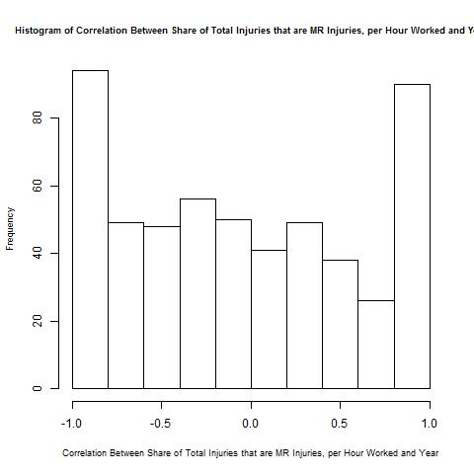

These plots show that both for both correlations, there are a high share of mines with extremely positive or negative correlations, with the rest fairly evenly distributed across the range of possible correlations.